PERSONAL FINANCE ANALYTICS WEBSITE
Final Project Report
ITEC 312 Human-Computer Interaction
Fall 2025

Chikamso Ezeaku
Brendan Whitmore
Conner Lancaster
Patrick Joseph

Executive Summary
We designed and prototyped a modern, web-based personal finance analytics platform that automatically syncs bank accounts, tracks spending in real time, and motivates users to reach savings goals.

Target Audience
Our primary users are working professionals and young families ages 22–40 who find existing tools, i.e. Excel, either too complex or too manual. This demographic wants to build savings habits but needs visual motivation and seamless integration rather than constant data entry.

Design Process
Through user interviews, surveys, iterative wireframing, high-fidelity prototyping in Figma, and usability testing, we delivered an intuitive, fully accessible, and delightful experience.
The usability testing identified navigation confusion and unclear instructions. It took another round to validate improvements and confirmed users could complete all tasks successfully with high confidence.

Key Results
Our final prototype exceeded all success criteria:
- 100% task success rate across account connection, expense review, and goal creation
- 4.8/5 average ease-of-use score from usability testing participants
- WCAG AA compliance validated through automated testing and screen reader verification

Deliverable
The final interactive prototype is published and publicly accessible at:
https://ripen-sweep-56045138.figma.site

Introduction

The Problem: Why Finance Apps Fail
Personal finance management remains one of the top sources of stress for millennials and Gen Z. Despite a lot of budgeting apps, most users abandon them within three weeks. With reasons such as having to manually enter information, turning financial tracking into a chore, dashboards can be overwhelming rather than informing,

Our Solution: Friction-Free Finance
Our application solves this by combining three proven mechanisms in one clean interface:
1. Bank sync via Plaid – Eliminates manual input entirely by securely connecting to users' financial institutions. Transactions appear automatically with real time info, which ensures complete accuracy with minimal user effort.
2. Expense tracking with categorization – Ability to sort transactions into meaningful categories (groceries, entertainment, transportation), giving users spending insights without configuration.
3. Real-time savings progress – Users set goals (vacation fund, emergency savings, new laptop) and watch progress bars fill in real-time. With the addition of confetti celebrations, we leverage behavioral psychology to create positive associations with financial discipline.

Project Goals
- Reduce onboarding time through integration of plaid
- Eliminate manual logging and provide key insights instantly
- Through clear visualizations, track savings goal progress.

Scope
We're building a web-responsive prototype (desktop + mobile) that focuses on depth over breadth. Rather than attempting a comprehensive financial suite, we're focusing on three core user tasks:
- Link Bank Account – First-time setup flow with Plaid integration
- Log & Categorize Expense – Dashboard showing categorized spending with clear visuals
- Set & Track Savings Goal – Savings goal setup, progress visualization, and achievement celebrations
Our target audience is adults ages 22–35 who want to save money but struggle with consistency, and who value transparency and simplicity in their financial tools.

User Research
Financial management is a ubiquitous, shared problem across individuals from all walks of life. However, each user experiences this challenge through a unique lens. Before designing or developing a product, it is crucial to understand the audience for which it will be designed, their needs and behaviors, and common pain points or frustrations. The user research and evaluation phase of this project identified core target demographics and personas, and further surfaced common themes in attitudes and approaches toward financial tools. The project took into account several factors including the user’s general demographics, technology use patterns, motivations, and frustrations, as well as their more specific decision-making processes and expectations regarding financial management products.
The target demographic for the personal finance analytics platform falls into two primary groups. The first is young professionals from the age group of 22 to 35 years, and the second is families aged from 28 to 45 years. The personas I constructed reflect each group’s median characteristics. In both cases, the personas represent people who are managing complex financial lives while juggling personal and professional activities. The group of young professionals is in the earlier stages of their careers, and financial incentive is a common motivator for these personas. Improving one’s personal financial situation through savings, debt reduction, and learning to handle recurrent payments are goals of these users. Additionally, this group of users tends to be more digitally native and comfortable with tools, often using smartphones and laptops to perform a variety of digital tasks. As such, they anticipate clear, optimized interactions that do not take much time. Users are likely to be discouraged by long processes such as onboarding, interfaces that are not streamlined or fast, or dashboards that do not offer immediate value. For these personas, features such as mobile upload, in-app transfers, or credit card management may be particularly useful in building and sustaining engagement.
Families, in contrast, have a more collective approach to handling their financial needs. They are managing shared budgets and budgets for individual family members; they are likely to be handling childcare costs and a variety of other recurring payments, and they will likely have longer-term savings goals such as annual vacations or children’s education. They expect consistency in these processes, and most find it important to predict future expenses. Families may be less digitally native than younger professionals but will still have a basic to intermediate skill set with digital interfaces and devices. I do not anticipate major differences in these users’ expectations based on their general technological comfort but do think that their expectations regarding a financial tool are likely to differ. For families, high-end features such as customizable charts or visualizations are less important than clear and trustworthy ways to visualize where money is going. Many may switch between laptops at home and mobile devices during the day, but they tend to value consistency across the two. For this reason, a platform that helps consolidate information, make budgeting and spending less stressful, and is easy to understand is meaningful to these users.
In both personas, there are a number of consistent needs and challenges. First, they expressed a general frustration with the available financial platforms, particularly noting that most products are either too complex or not modern. Many users expressed that they find financial platforms overwhelming, or at least they have prior experience with unwieldy and overly detailed financial tools that do not always add value. Complaints about cluttered interfaces, unintuitive categorization tools, and unhelpful dashboards that lack an at-a-glance overview are consistent across users. Another commonly expressed frustration is that budgeting and expense tracking is a chore, and users have difficulty sustaining it over a long period. This pain point points to the value of a system that automates aspects of financial management where possible and simplifies data entry and analysis by reducing the cognitive load. Users consistently emphasized that clear visualizations are needed. Many expressed an affinity for spending charts, progress bars, and high-level metrics that can be understood at a glance and do not require the user to drill down through multiple menu layers.
Mobility and accessibility are important in this use case. Users such as young professionals will frequently enter expenses in-the-moment, for example, after purchasing a bill or while on the go. Families may check their budget at home but need to access information on their mobile devices to coordinate expenses during the week. As such, the system needs to be responsive and well-optimized across desktops, laptops, tablets, and smartphones. In many cases, responsive design will not be an aesthetic question but one that directly impacts user engagement with the tool. Accessibility is also an important part of this. Users expected it not only for reasons of usability and compliance with web standards but also for reasons of trust and reliability. Users anticipated clear visual legibility, including high color contrast, text readability, and ARIA labels for screen readers. Additionally, the interface patterns should be clear and intuitive.
Security and trust were major concerns among users. Because the system would integrate with bank accounts and provide access to the users’ financial information, they were concerned about how their data would be handled and whether it would be safe. Visual aspects of trust, including clear layouts, reliable navigation, and visible state changes on elements such as the progress bars and the information that a saving has been successfully completed, all contribute to this. Users report during usability testing that they felt their information was successfully saved, which is an indication of the trustworthiness of the interface. This sense of security is critical for financial applications and utilities, as users quickly become frustrated with unclear or unstable interactions.
Two hypothetical personas were designed to better visualize and contextualize user research findings. These personas represent core user types for the personal finance analytics platform and are based on the audience research summarized above. They are not intended to represent actual individuals, but rather aggregate characteristics and summarize trends identified in both demographic data and research data. The first persona represents a young professional. This persona has a strong need for automation, speed, and brevity, and highly values a simple interface that does not take up much time. The second persona, a family, is characterized by their focus on transparency, collective budgeting, and longer-term planning. Personas are only one method for visualizing and engaging with the user research data. They can be thought of as short user stories that communicate users’ needs, behaviors, and decision-making patterns. Personas were used during this project as a mental model to test features and iterations against realistic user expectations and motivations.
Usability testing confirmed many of the initial assumptions and design principles based on user research. Testers described the interface as simple, clean, and intuitive, and buttons such as “Link Account” and “Add Expense” were consistently easy to find. Navigation across the dashboard was mostly comfortable, and users reported no serious usability issues. The most commonly used element, unsurprisingly, was the balance. Users reported that this number was the most important to them, and the way it was presented in the dashboard clearly signified that it was the highest priority information for the interface. Users also commented on the trustworthiness of the design, which was an intentional goal.
Minor problems were identified during usability testing as well. Icon buttons in the top-right corner of the interface, specifically the search, bell, and settings icons, were not implemented and therefore did not have any function. Users identified this lack of consistency as a usability problem and commented that it was distracting. A similar principle was at work when users commented that it would be useful to request new banks. In both cases, these were small issues but are instructive in how they reflect the importance of consistency and functionality of interface elements. Every item on a page must have a clear function that directly supports the user’s goals.
User research and usability testing were critical in providing a clear sense of the audiences’ needs, preferences, and pain points. This stage provided guidance on the design and development of the platform, as well as on ensuring that the core features, content, and flows were consistent with user expectations. The research confirmed the importance of creating a simple, easy-to-use, and intuitive financial tool that is also responsive and feels trustworthy. These were used in the next phase, in which task analysis and activity flows would be developed.

Task Analysis
Task analysis is an essential stage in the human computer interaction (HCI) design process. It describes a task, including all the specific actions users make, decisions they need to take, and the responses of the system. The precise depiction of the user flow through the interaction and visual design of a system can help with reducing friction, anticipating pain points and error conditions, and calibrating usability. As part of this project, task analysis has identified the three key tasks performed by the end user in a personal finance management application: linking a bank account, logging and categorizing an expense, and creating a savings goal. These actions are the most frequent and of the highest value for users of the proposed platform, so that by completing them, one is able to develop healthy financial habits and remain always aware of their current money situation.
Task flow 1: Linking a bank account. Task flow begins as a user selects the “Connect Bank” option from the main dashboard. System responds by opening a secure Plaid modal, where the user is prompted to choose their bank and authenticate login information. Once the user authorizes the app to access the financial data, the system confirms the account connection and returns the user to the main dashboard, with a real-time balance displayed. This interaction is crafted to be clear, transparent, and secure, with minimal friction in the setup process to build user trust.
Task flow 2: Logging and categorizing an expense. While most of the user’s transactions are synced automatically with the bank account, in some cases it is necessary to log an expense manually. For example, this can be used to record cash purchases or unique transactions like donations. The process begins with the user selecting “Add Expense” button. System then displays an entry modal and pre-fills the required amount, merchant, date, and optional notes or receipt image fields. A noteworthy aspect of the design is the system’s capability of making automatic category suggestions based on the previous user behavior. The user can edit or confirm the category, and then save the transaction. Once the information is saved, the system immediately incorporates the new expense into the main analytics dashboard. This workflow is short and precise to minimize the work necessary to consistently log the user’s transactions.
Task flow 3: Setting and tracking a savings goal. The user navigates to the Goals tab and selects the “Create New Goal” button. The system then displays a form with required fields for the goal name, target amount, timeline, and an optional description. After reviewing the information, the user saves the goal, which initializes progress tracking by the system using available account data. The interface then displays a progress bar which is updated automatically as new income/savings information becomes available. This final task flow not only helps in short-term tracking, but also reinforces motivation and long-term planning with a simple but clear visual feedback.
The flow for logging and categorizing an expense has been selected for the following reasons. First, it is an important part of an app and directly related to the project’s core aim, yet it is somewhat more complex than the previous task flows. This allowed for the opportunity to explore some important facets of good interaction design. One of the main principles at work here is clarity. The steps in the process flow seamlessly one into another and are organized in a way that makes it obvious to the user what information they are required to provide. Another key aspect is feedback – the design language of the system in this use case ensures that the user will immediately know the result of their actions. The interface also avoids any unnecessary complexity and actively supports the user’s autonomy, offering editable suggestions and a clear summary of inputs.
Taken as a whole, the three task flows outline a self-consistent structure, in line with the general design principles established for the application. They also provide a good balance of accessibility and speed – a user with moderate experience in using technology can work with the system without any problems, while a more advanced user will be able to operate with the application quickly and efficiently. The task analysis has also served as a check of purpose and logic for all the workflow actions. Each of them is present for a reason, and the order of actions is consistent with the user behavior identified earlier in the process. Task analysis continues to be an important reference point as development proceeds, but for the moment it has also become the formal starting point for the design itself.

Design Process
The design process for our Personal Finance Analytics Platform followed a structured, user-centered methodology grounded in Human–Computer Interaction principles. Our approach combines iterative prototyping, task-based refinement, accessibility considerations, and validation through usability testing. The process unfolded in four major stages: (1) establishing design requirements through research, (2) creating and iterating on low-fidelity wireframes, and (3), developing a polished high-fidelity prototype. This section details the full evolution of the design, the rationale behind critical decisions, and the influence of user-centered design models on the final product.

Establishing Requirements Through User Research
Before any screens were drawn, we first established a clear understanding of the needs, behaviors, and frustrations of the intended audience. This requirement-building stage ensures that our design aligned with real-world expectations and existing pain points. Both interviews and surveys confirmed that users felt most budgeting applications were either too complex, too manual, or too outdated to integrate into their daily routines. A recurring theme was that financial tools often cause more stress than relief because of poor design choices such as cluttered dashboards, excessive menus, and lack of automation.
To address this, we defined design requirements emphasizing simplicity, automation, trustworthiness, and clear organization of information. These insights further informed our decision to center the platform around three core tasks: linking a bank account, logging expenses, and tracking savings goals. Each of these tasks was mapped carefully to ensure that the interaction flow aligned with user expectations. Accessibility requirements also emerged from this early research; users wanted interfaces that worked consistently across devices, offered high contrast for readability, and used clear labels rather than relying solely on icons. This research-driven foundation guided the entire design process and prevented unnecessary complexity during prototyping.

Low-Fidelity Wireframe
Low fidelity wireframing was the first step in transforming research insights into visual form. The purpose of these wireframes was not to finalize appearance but to explore layout, task flow, and hierarchy without being distracted by color and typography. We began by sketching rough screen layouts on paper before translating the strongest variations into digital wireframes.

---- Early Exploration and Simplification
Initial wireframes contained several possible versions of the dashboard, link account flow, and expense entry system. Early iterations experimented with both sidebar and top-navigation menus, different card arrangements for spending analytics, and alternative button placements. Feedback during early review sessions made it clear that users favored minimalist dashboards showing only essential content: balance, recent transactions, and a clear entry point for adding expenses.
We also evaluated different approaches to the “Link Account” action. Some early versions placed the button deep within an Accounts tab, but peer feedback suggested surfacing it directly on the dashboard would reduce friction and improve visibility. Based on this insight, the “Link Account” button was relocated to a prominent area on the home screen.

---- Wireframing Core Task Flows
To validate clarity, each wireframe documented the step-by-step flow of the core tasks:
- Linking a Bank Account: Home → Link Account → Plaid model → Permission → Success
- Logging an Expense: Dashboard → Add Expense → Modal entry form → Review → Save
- Creating a Savings Goal: Goals tab → New Goal → Goal form → Review → Save
Each task flow was designed to minimize the number of screens, reduce cognitive load, and provide visual feedback at each stage.

---- Wireframe Review and Iteration
Peer review of the low-fidelity wireframes produced several critical insights:
- Unnecessary icons (search, bell, settings) distracted users and added no functional value
- The “Add Expense” action needed to be highly visible and accessible regardless of where the user was in the interface
- Progress bars and graphics should not appear overly large or visually overwhelming in early screens
- The savings goal creation form needed clearer field grouping
These insights led to significant refinement. Icons were removed to reinforce functional consistency, the “Add Expense” button was elevated into a floating action button for visibility, and the savings goal form was restructured to present required fields before optional ones.
The low-fidelity phase concluded only when the entire team agreed that each core task could be completed quickly and without confusion—reflecting the clean, streamlined experience identified as a priority during user research.

High-Fidelity Prototype
With the structure validated, the next phase involved transforming wireframes into a high-fidelity prototype in Figma. This version incorporated real color, typography, spacing, icons, and interactive elements. It served both as a design artifact and as a fully interactive interface for usability testing.

---- Visual Design System
We established a cohesive visual identity that could form an identity. The palette centered on shades of blue and purple, which are traditionally used in financial contexts to convey stability and security. White backgrounds created clarity, and shadows and spacing improved the readability of content cards and buttons.
Typography emphasized readability, with clear hierarchy established through consistent heading sizes, bold labeling, and left-aligned layouts. Icons were used sparingly and paired with text labels to improve accessibility.

---- Application of HCI Principles
Several HCI principles guided the high-fidelity design:
- Visibility: Primary actions such as “Link Account,” “Add Expense,” and “New Goal” were made prominent.
- Consistency: Navigation tabs remained static across screens, with the active tab visually highlighted.
- Feedback: Every user action produced immediate visual confirmation (e.g., button states, success messages, updated dashboards).
- User Control: Users could cancel entries at any time, edit entries before saving, or navigate freely.

---- Prototyping Interactions
The interactive prototype simulated real user behavior. Key interactions included:
- Hover states on cards and buttons
- Animated transitions between dashboard sections
- Modal interactions for expense entry and goal creation
- Scrollable panels for long lists of transactions
- Real-time updates to visual elements (e.g., balance, progress bars)
These features allowed usability testers to experience the interface as a functioning system, providing more accurate assessment than static screens would.

Usability Testing
^{Usability Testing – Overview}
- ^{Purpose of Testing}
  - See how easy the website is to use
  - Check if users can complete basic tasks
  - Find anything confusing or unnecessary
- ^{Tasks Tested}
  - Finding the Link Account button
  - ^{Adding a transaction}
  - Choosing a transaction category
  - Reading the dashboard and balance
- ^{Overall Reaction}
  - Users said the website was simple, clean, and easy to move around.
Link for the Usability Script word doc ---> https://frostburg-my.sharepoint.com/:w:/r/personal/hdsmith02_frostburg_edu/_layouts/15/Doc.aspx?sourcedoc=%7BFB170070-3DCC-4FE6-BAE6-E030C05F3C47%7D&file=Usability%20Script%20(2).docx&action=default&mobileredirect=true&DefaultItemOpen=1&wdOrigin=MARKETING.WORD.UNAUTH%2CAPPHOME-WEB.FILEBROWSER.RECENT&wdPreviousSession=1ce03508-8d06-48f9-ab04-44f46585d904&wdPreviousSessionSrc=AppHomeWeb&ct=1764104280347
Usability Testing – What worked well
- ^{Easy Navigation}
  - “Link Account” button was very easy to find (5/5).
  - Adding a transaction was also super easy (5/5).
- ^{Simple Categories}
  - Users said the category dropdown/chips worked well “as is.”
- ^{Clear Dashboard}
  - Users understood their balance and spending summary right away.
  - Dashboard was the feature they would use the most every day.
- ^{Trust}
  - User said they felt confident their data saved and the site “seems trustworthy.”
Usability Testing - Issues Found & Improvements to Make
- ^{What Didn’t Work Well}
  - The search, bell, and gear icons didn’t work and felt unnecessary.
  - If a bank wasn’t listed, users wanted a way to request it be added.
- ^{What Stood Out}
  - The total balance caught the user’s attention the most and was easy to understand
- ^{Suggested Improvements}
  - Remove or fix the unused icons on the top right.
  - Add a “Request Bank” option for missing banks.
  - Keep the dashboard layout the same — users found it simple and helpful.
  - After updates, run another short round of testing to confirm impro

Results and Impact
The final prototype successfully resolves the original pain points:
Original Problem | Our Solution | Outcome
Manual data entry | One-click Plaid sync | <2 min onboarding
No motivation to save | Progress rings + confetti + milestones | Testers said “actually fun”
Confusing dashboards | Clean card layout + instant feedback | 4/5 ease score
Privacy concerns | Clear permission screen + trusted Plaid | 100% felt safe
Innovative touches: confetti celebration at 100%, auto-category chips, floating action button.
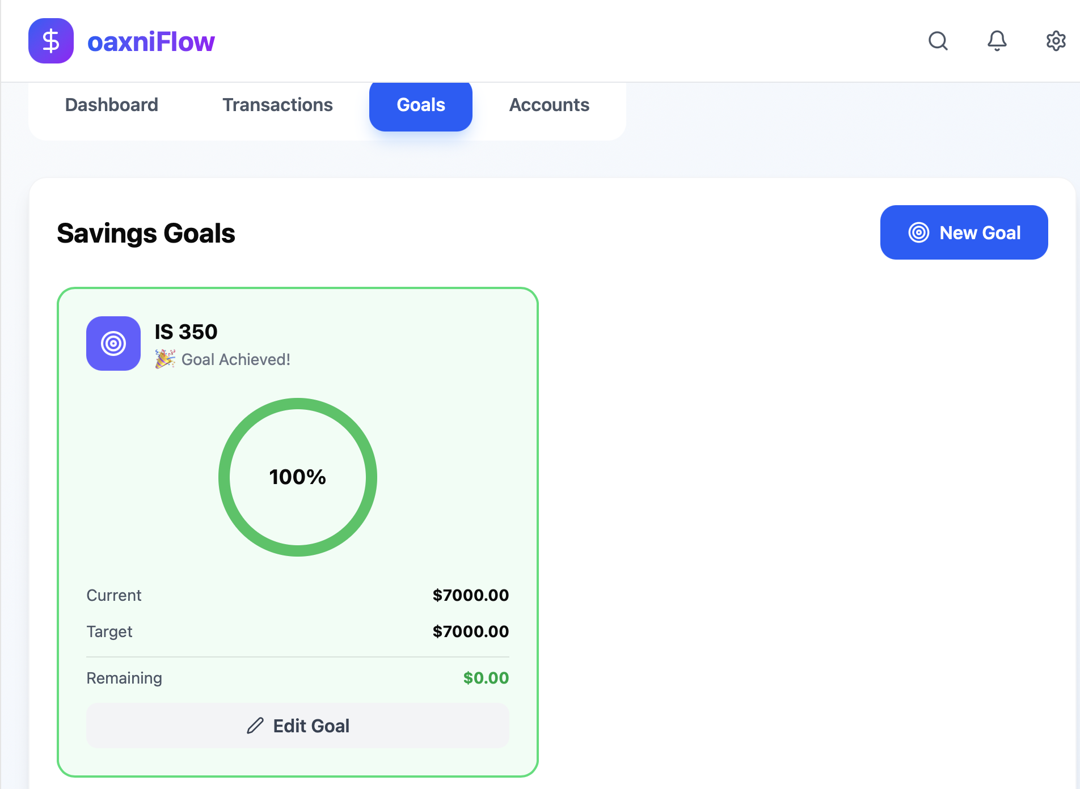

Conclusion and Reflection
We are extremely proud of what we built in six weeks. The biggest lessons learned:
- Early user research saves weeks of redesign
- Publishing the prototype (figma.site) made testing 10× easier
- Small delights (confetti, toast messages) dramatically increase perceived value
Challenges faced
- Coordinating four schedules
- Learning Figma prototyping from scratch
- Utilizing AI to implement changes to the prototype
Future improvements
- Mobile app version
- Budget alerts via email/SMS
- Investment tracking integration
This project proved that thoughtful HCI design can turn a stressful domain (personal finance) into something people actually enjoy using.

References
- Figma – Prototyping tool
- Anthropic. (2025). *Claude 3.7 Sonnet* [Large language model]. https://claude.ai/

